PAPER SUMMARY REPORT

Feasibility of Digital Health Services for Educating Community People Regarding Lifestyle Modification Combating Noncommunicable Diseases
Authors | Mithila Faruque, Mohammad Badruddozza Mia, Moinul H. Chowdhury, Farhana Sarker, Khondaker A. Mamun
Venue | HCI International 2019 (HCII), N. Streitz & S. Konomi (Eds.), LNCS 11587, pp. 333–345, Springer
DOI | 10.1007/978-3-030-21935-2_25
Affiliations | BUHS; UIU (School of Business & AIMS Lab, CSE); CMED Health Ltd.; ULAB
Research type | Feasibility / evaluation study using Action Research (mixed methods)
Keywords | Mobile health app, usability, NCDs, prevention, health records, smart devices

1. Introduction and Motivation
Mobile health (mHealth) is growing fast: by 2015 there were over 165,000 health apps, and 34% of phone owners had at least one. However, there is little evidence on the usability and efficacy of commercially launched apps, because academic research moves much more slowly than commercial app development.
Bangladesh is going through a rapid epidemiological transition. Chronic-disease deaths in rural areas rose from 8% (1986) to 68% (2006); about 21% of people have hypertension and over 10% have diabetes. The paper notes that lifestyle change could prevent up to 90% of strokes, 80% of heart attacks and 73% of diabetes, so preventive care and regular monitoring are key.
CMED Health is an IoT-enabled, AI-driven, cloud-based preventive and primary healthcare platform. Portable smart devices (BP, glucose, pulse, SpO₂, temperature, weight/height/BMI) connect to a smartphone app. A Clinical Decision Support System (CDSS) assesses risk, gives instant colour-coded feedback and advice, and refers at-risk users to a doctor. Records are stored in the cloud and shown on a management dashboard.

2. Objective
To assess the content, usability and efficacy of the commercially launched CMED digital healthcare platform for preventing major NCDs (CVD, hypertension, diabetes) and improving primary care in rural Bangladesh, and to judge its feasibility from the views of service receivers, providers and managers.

3. Methodology
- Design: triangulation of quantitative, qualitative and participant-observation methods following Action Research principles.
- Setting: pilot in 21 villages of Dhamrai upazila (Dhaka district), covering more than 7,000 households and about 32,000 people, over a 6-month pilot. Partners were CMED Health, UIU AIMS Lab, BUHS, PKSF and the local NGO SOJAG.
- Four evaluation strands: (a) Content analysis – CDSS cut-offs and interpretations checked against the National Protocol on Diabetes and Hypertension and reviewed by stakeholders; (b) Expert validation of health advice at a policy-level workshop; (c) Usability testing through iterative test-and-fix with field workers in their real working environment; (d) Efficacy testing – device/app measurements compared with manual, traditional methods.
- Data collection: semi-structured questionnaire with 393 service receivers; Key Informant Interviews with service-team members, senior staff and village opinion leaders; 4 Focus Group Discussions (2 with health workers – smart vs. manual devices – and 2 with receivers in two villages), recorded and transcribed.
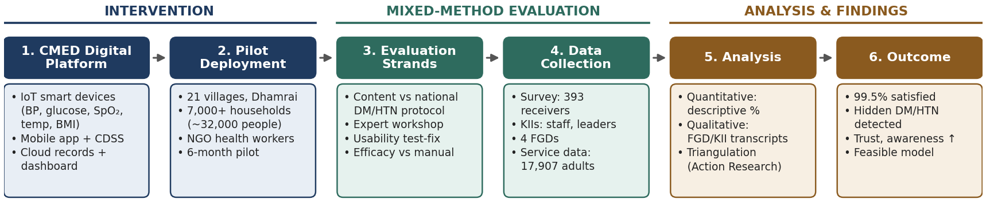
Figure 1. Methodology block diagram – CMED platform pilot and mixed-method (Action Research) feasibility evaluation.

4. Key Results
Of 32,122 people, 17,907 adults received screening through the platform. Measurements taken:
Measure | BP | Glucose | BMI | SpO₂ | MUAC (children <5)
No. of measurements | 36,326 | 1,348 | 34,721 | 38,400 | 1,229

- Acceptance: 99.5% of respondents were satisfied (92.1% of respondents were female because surveys were done in the daytime). Most said the digital method was better than the old manual one.
- Reasons for liking it: digital and smart-looking (27.3%), instant on-screen results (14.7%), comparison with previous records (14.4%), instant advice (12.8%), less time and accurate (3.8%).
- Better detection: self-reported vs. screened diabetes went from 2.7% to 15.8%, and hypertension from 6.5% to 11.5%, showing many undiagnosed cases.
- Qualitative findings: health workers could now easily measure BMI, felt more respected and trusted, and saw villagers change behaviour (for example, starting to walk regularly). Receivers valued seeing results themselves in Bangla and keeping records for doctor visits.
- Only 1.6% were dissatisfied, mainly because services and medicine were not entirely free.

5. Discussion
The discussion stresses the context: NCDs cause 67% of deaths in Bangladesh, out-of-pocket spending is 67% of total health costs, and only 10% of spending goes to prevention, while over 70% of people live in rural areas. The platform brought several feasibility benefits: managers can supervise health workers, data is available for research, the dashboard gives policymakers population-level views, data is collected and recorded in one step, the app works offline, worker workload fell, and community awareness grew through CDSS advice. The data could also support targeted interventions and health-insurance design.

6. Limitations
- The pilot was too short to measure actual behaviour change.
- The survey sample was heavily skewed towards women, and evidence is mostly self-reported satisfaction (there was no control group).
- The paper was authored partly by the platform developer (CMED), which may bias the findings. The pilot period is stated as July–December 2019, which seems inconsistent with the 2019 publication date.

7. Conclusion and Takeaway
Service providers and receivers both judged the CMED smart-device + app + CDSS model suitable and feasible for community-level NCD screening. It raised awareness and trust and revealed undiagnosed diabetes and hypertension. The authors propose it as a primary-prevention model for low-resource settings such as rural Bangladesh. This paper is the feasibility precursor to the larger 18-month efficacy study published in BMC Public Health (2025).

